**Name: Michelle Lim**

**Web Development Project**

**Task Breakdown**

|  |  |  |
| --- | --- | --- |
| **Task** | **Date Due**  **(Planned)** | **Date Due**  **(Actual)** |
| 1. low and mid-fidelity wireframes | 3/21 | 3/21 |
| 2. high fidelity wireframes | 3/28 | 3/28 |
| 3. 10 user stories organized by priority | 3/24 | 3/28 |
| 4.paragraph explaining how first-time users navigate website | 3/28 | 3/28 |
| 5.customer online order form for burnt almond torte cake | 3/26 | 3/28 |
| 6. mobile responsiveness screen | 3/26 | 3/28 |
| 7. visiting hours | 3/24 | 3/28 |
| 8. visitor inquiry form | 3/26 | 3/28 |
| 9. five links to external websites | 3/26 | 3/28 |
| 10. special feature of almond torte, two occasions | 3/27 | 3/28 |

Mid-Fidelity Wireframes

Home Page

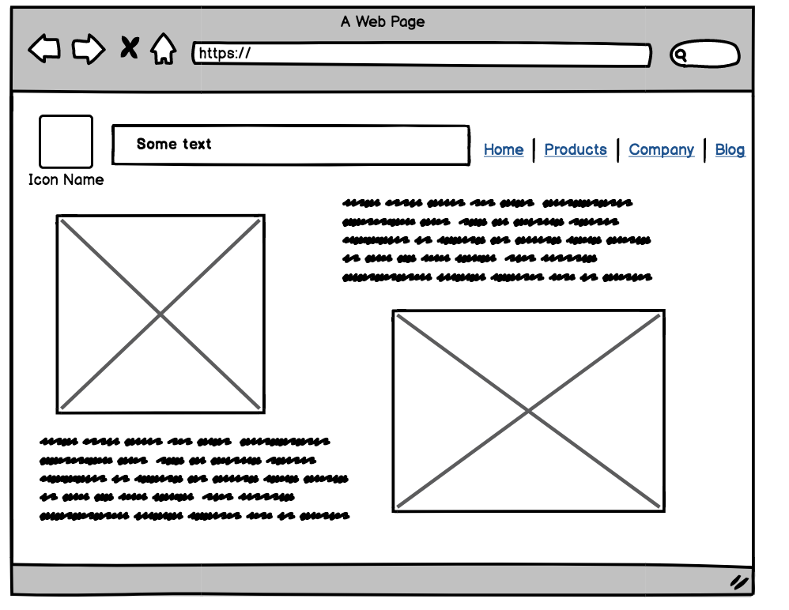

Online Order Form Page

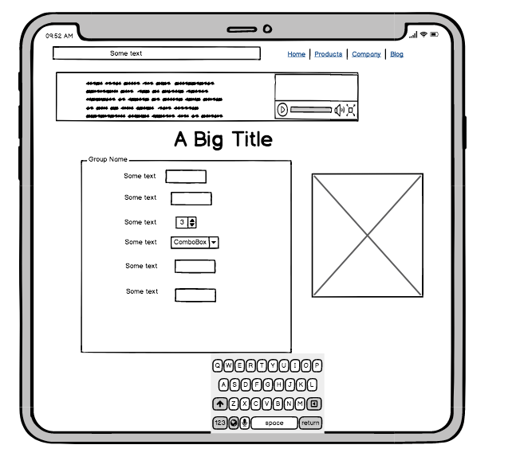

About Page

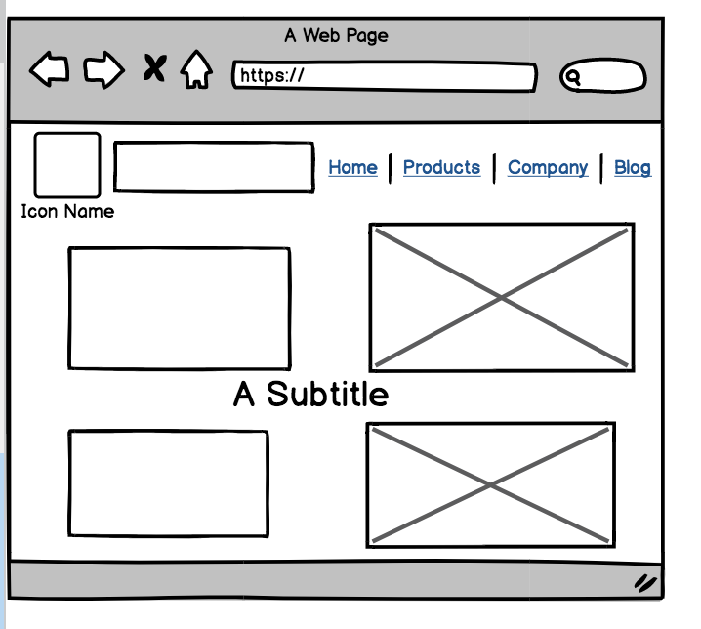

Weddings Page

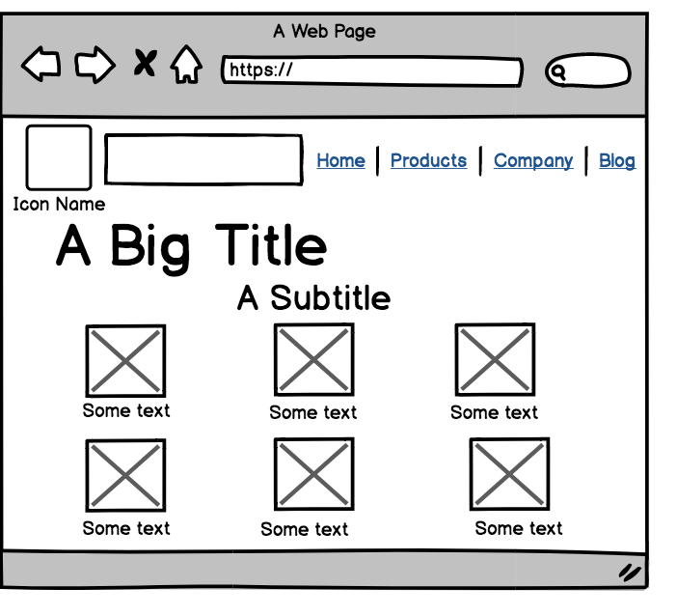

Birthdays Page



Contact Form Page

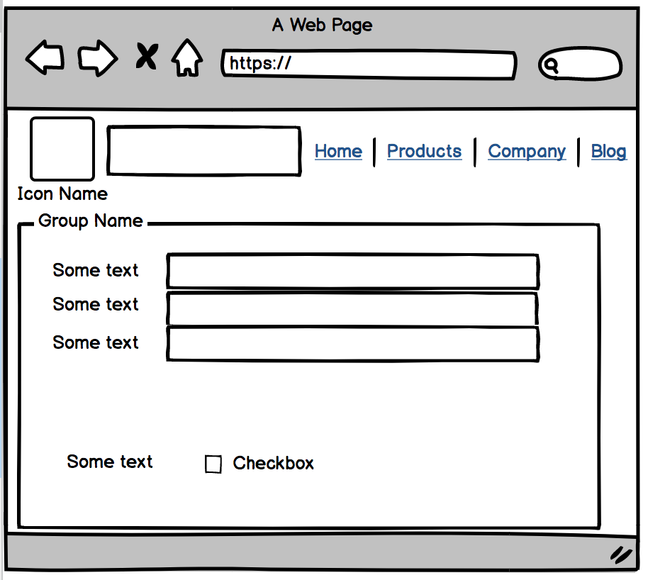

Location Page

